OFreq Dynamics
Wave Input Calculation

Nicholas Barczak
April 15, 2013
Rev: 1.0
DMS1303-001-110-07
Revision History
Revision | Date | Changes | Approval
1.00 | Dec 30, 1999 | Initial Issue

Prepared By
Datawave Marine Science
3500 27th Pl West
Apt 423
Seattle, WA 98199

www.dmsonline.us

Table Of Contents
1 Introduction 4
2 General Approach 4
3 Inputs 6
4 Program Sequence 7
4.1 Calculate Frequency Step 7
4.2 Select Wave Environment Model 7
4.3 Select Closest Wave Directions 7
4.4 Interpolate for Wave Frequency 8
4.5 Interpolate for Wave Directions 9
4.6 Calculate Wave Amplitude 9
5 Conclusion 9
6 References 11

- Introduction
One of the first steps for oFreq is to establish the wave amplitude. This becomes an important number for many subsequent calculations. But the wave amplitude is not a constant. Due to the complexity of seakeeping and ocean waves, the wave amplitude varies with both wave direction and wave frequency. Naval architects have devised several methods for how to handle this variation. Only the most minimal approach is currently implemented in oFreq. This document details that approach. It includes the overall strategy, and the details of each step.
- General Approach
Figure 2.1 shows a flowchart with the total operations for calculations of wave amplitude. In general terms, the calculations take wave frequency and wave direction as inputs. The program then selects from a list and finds the two wave directions closest to the input direction. Each available wave direction contains a wave spectrum, which specifies how wave energy varies with wave frequency. The program uses the wave spectrum from each of the two selected frequencies to calculate the wave energy for the given wave frequency. Next it interpolates that results between the two selected directions to get the actual wave energy for the input wave direction and frequency. But the information is still in wave energy. Finally, the program converts from wave energy to wave amplitude.

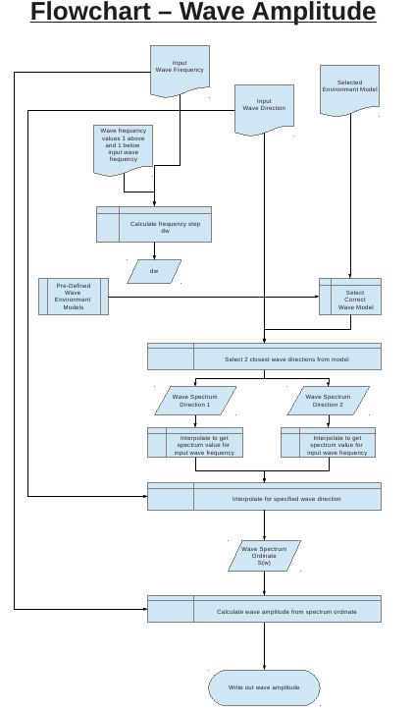Figure 2.1: Flowchart for Wave Amplitude Calculation
To understand the wave amplitude calculation requires a brief background on how naval architects represent a seastate.
A seastate is a series of waves all together, and each wave acts at a different frequency. But some waves occur more often than others. They have a higher probability of occurrence. To capture this variation, naval architects devised a wave energy spectrum. This is a table or function relating wave energy to wave frequency. Higher energy values mean a higher probability of occurrence. For a given wave frequency, the function returns a wave energy, which is later converted into wave amplitude.
The issue is further complicated by the fact that ocean waves occur in multiple directions, simultaneously. The naval architects accommodate this by defining a series of wave spectrums, one for each direction. The number of directions defined can vary with the desired level of accuracy. But each direction will contain the direction associated with it, and a wave spectrum that varies with wave frequency.
This general approach is now converted into a series of functions and procedures that depend on very few data inputs.
- Inputs
The program to calculate wave amplitude requires four inputs.
- Environment Model (model)
- Wave Direction (α_{input})
- Wave Frequency (ω_{input})
- Wave frequency value of 1 below input wave frequency (ω₀)
An environment model is a combination of wave spectrums and the wave direction associated with each wave spectrum. The program may have multiple environment models defined. The input for environment model is just a string to specify which environment model to use. The string matches the name given to an environment model. If the string does not match any model, the program throws an error.
The wave direction input is the desired direction of wave propagation. Direction is specified as an angle in radians, with 0 rad as True North, positive moving west.
The wave frequency input is the desired wave frequency in radians per second (rad/s).
Finally, the program must know the value of the wave frequency immediately below the input wave frequency. This is the frequency from the global list of wave frequencies used for the analysis. If this input is the first item in the global list, then the frequency immediately below is 0 rad/s.
- Program Sequence
The program goes through the following steps to calculate wave amplitude.
- Calculate frequency step
- Select wave environment model
- Select closest wave directions
- Interpolate for wave frequency
- Interpolate for wave direction
- Calculate wave amplitude
The math and details for each step are provided below.
  - Calculate Frequency Step
The first step is to calculate the wave frequency step. This gets used later for calculating wave amplitude. The frequency step is the input frequency minus the frequency of one below.
Equation 4.1
Where:
ω_{input} = Input wave frequency (rad/s).
ω₀ = Frequency one below the input wave frequency.

  - Select Wave Environment Model
First, the program selects the appropriate wave environment model, based on the input. It then passes the values for the input wave frequency, input wave direction, and input frequency step to the environment model. All other calculations are handled internally by the environment model.
  - Select Closest Wave Directions
Each wave environment model may have anywhere from 1 to an unlimited number of wave directions defined, and each wave direction contains its own wave spectrum function. The environment model first elects the two wave directions that are closest to the input wave direction.
If only one wave direction is defined in the environment model, the program can use the same direction for both entries. Eventually, the program will interpolate between the two wave directions. If only one direction is defined, it may use this opportunity to recognize that direction interpolation is not required at a later point.
If the input direction is outside the available list of defined wave directions, the program can just use whichever direction is closest and avoid interpolation between directions.
  - Interpolate For Wave Frequency
    - Calculations External To Energy Spectrum Function
Each wave direction has its own wave spectrum function defined. Each function will already contain its own parameters, which were defined by the user in the initial setup. The only input the program needs to supply now is the wave frequency. The energy spectrum function is self contained because it can change depending on what the original user inputs were. The program may also need to specify a text string of which wave spectrum function was requested.
The wave frequency supplied to the energy spectrum is not the same as the input wave frequency. For reasons of numerical accuracy, the input frequency is modified slightly.
Equation 4.2
Where:
ω₁ = Input wave frequency for the energy spectrum function.
ω_{input} = Input wave frequency specified and given to the wave environment model.
δω = Wave frequency step.

The wave spectrum function returns a value of the wave energy at the given input frequency. Each wave direction also has a scaling factor defined as part of the wave environment model. The returned value from the energy spectrum function is multiplied by this scaling factor.
Equation 4.3
Where:
S(α₁) = Wave energy for that wave direction.
λ = Scaling factor for energy spectrum function.
f_{spec}(ω₁) = Returned value from the wave energy spectrum.

This process of calculation repeats itself for the two wave directions selected by the environment model. Often, both directions will use the same wave energy spectrum, but this is not always the case. The user has the ability to specify different wave energy spectrums for each individual wave direction.
    - Calculations Internal To Energy Spectrum Function
Internally, the calculations for wave energy can vary greatly, depending on which energy spectrum is selected. These more complex wave energy functions are outside the scope of this project. For now, a simple interpolation spectrum is the only function defined.
The function contains an array of wave frequencies and matching spectrum energy values. The function takes the supplied input wave frequency (ω₁) and interpolates to return the spectrum energy. If the supplied input frequency is outside the range of defined frequencies, the function returns the spectrum value from the frequency closest to the request frequency. It does not attempt to extrapolate out to the requested frequency.
  - Interpolate For Wave Directions
The environment model now has two values of wave energy, one for each wave direction. It then interpolates between these two values for the requested wave direction. If there was only one wave direction defined, the program may elect to bypass interpolation and directly return the value for that wave direction.
If the requested wave direction falls outside the range of defined wave directions, the program will return the value from the closest wave direction. It will not attempt to extrapolate out to the requested wave direction.
  - Calculate Wave Amplitude
Finally, the program calculates wave amplitude from the returned value for wave energy, for the given wave frequency and direction.
Equation 4.4
Where:
Ϛ₀ = Output wave amplitude (m).
S(α_{input}) = Wave energy for specified wave direction.
δω = Wave frequency step.

The wave environment model then returns the calculated value for wave amplitude.
Note that future design features may also request the wave environment model to return the wave spectrum energy directly, without converting to wave amplitude.
- Conclusion
This document has defined the procedure for calculating wave amplitude given a wave environment model, and specified values for wave frequency and wave direction. This procedure will be used many times by the program for processing hydrodynamic data.

- References

